2015考研临考英语一作文终极预测

第一部分：作文预测

大作文话题类型：1. 社会现象类； 2. 抽象品质及社会问题类
预测话题包括：1. 网络类（网购、微博、微信等新现象）；2. 抽象品质类（梦想与行动、创新、 坚持等）3. 环境类（交通状况、动物/资源保护、节约型社会等）

应用文考察类型：书信
预测书信种类：投诉信、咨询信、请求信、祝贺信、申请信、感谢信

第二部分：部分预测作文范文（跨考教育英语教研室张老师提醒大家，划线部分为建议背诵句型，括号内容为可以替换内容）

大作文预测话题一：网络类（网购、微博、微信等新现象）

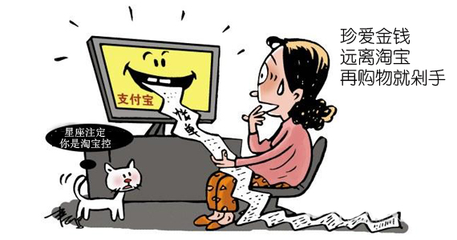
What is subtly demonstrated in the above drawing is that in front of a desktop sits a fashionable lady who is staring at the screen with shocked expression wearing on cheeks and huge sweat dropping from her forehead. What is spit from the computer is the lengthy Alipay bill, which can almost be spread as long as two meters. The caption above reads that you should keep away from Taobao and cherish your income.
The objective of the drawer is to show us that utmost attention should be paid to shopping online, which has exerted profound impact on the daily life of the average individuals. We can easily recognize its advantages as follows: e-commerce, which is extremely convenient, can save us a great amount of precious time and we can buy products everywhere we want as long as we can surf online. However, for all the advantages mentioned above, online trading is by no means without its limitations as listed below: we may be cheated by some online retailers, which might be a potential threat to our bank accounts.
Accordingly, it is imperative for us to take drastic measures. For one thing, we should appeal to the authorities to make strict legislations to severely punish those who deliberately spoil the interests of online customers. For another, we should enhance the awareness of residents that rational purchasing is conducive to our income management. Only in this way can we maximize the merits and minimize the demerits of online purchasing.

大作文预测话题二：抽象品质类（梦想与行动、创新、 坚持等）
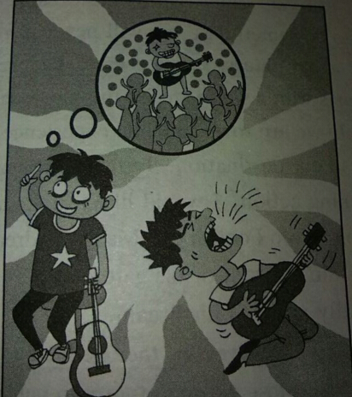
Wise people used to say that taking actions is of utmost significance in our daily life. This is most vividly illustrated in the given picture, which shows that two young boys both holding guitar are playing different life situations. The boy on the left is daydreaming about the day he gives a perfect concert and is admired by all the fans, while the boy on the right is practicing the guitar and singing skill persistently.
Studying it further, it is easy to figure out that taking actions is the only way to fulfill our dream. Our country, for example, has developed rapidly in terms of economy and science and technology. We have accomplished in about two decades what other emerging countries used to achieve in a century. There is no denying that it is the perseverance and taking actions that really realize the promise they made. If you never take action to do something, you will never have a chance to win. For example, a great number of students choose to take part in the National Entrance Exam for master’s degree. However, those who dreamed of becoming the postgraduates without taking any actions are even tremble at the thought of taking the exam, most of them are escaping the classroom when the first exam is over.
In a word, I believe, just like Forrest Gump said: “Life is like a box of chocolates：you never know what you’re gonna get. ” Unless you have the awareness that action speaks louder than the word.

大作文预测话题三：环境类（交通状况、动物/资源保护、节约型社会等）

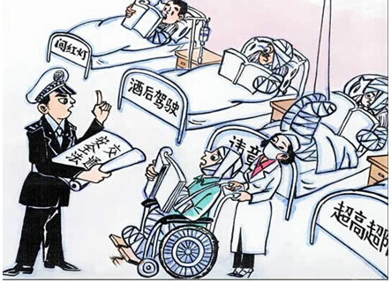
（Common as it is, it has deep implication）. As is vividly shown in the cartoon, at least five patients are staying in one hospital who are injured because of jay-walking, driving after drinking and disregarding of the laws. If we take a closer watch, it is of little difficulty to find that one police is patiently explicating the traffic laws to one injured person, standing at a wheel chair which is pushed by one nurse.
There is no doubt that it describes a common phenomenon in our society that traffic problems are more and more severe and what might trigger this affair? （For my part, the following two are of utmost importance.） For one part, the general public have failed to realize the importance of abiding by the traffic regulations and laws（and a big deal of the attention have been distracted by the so-called“great affair”）. Once some drivers easily disregard the traffic signals, so do other drivers who intend to obey the laws. Moreover, the current state of affairs depicted in the drawing, may have been encouraged, though not justified, by the lack of severe legal penalty. If someone does disorderly parking or drives under the influence of alcohol, the punishment is not so harsh that the drivers could afford to learn a heavy lesson from the fine as to never do it again . (If we let this situation continue as it is, ultimately, our society will suffer a great destruction.)
It is advisable for us to take steps to reverse this current evil trend. On one hand, we should cultivate the awareness of people that everyone needs to reflect on his or her uncivilized conducts and strengthen his self-discipline. On the other hand, it is high time that more severe and sound laws and regulations should be introduced to harness and curb this matter. Only in this way, can we crack the hard nut and embrace a bright future.

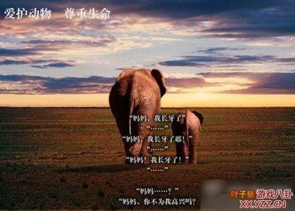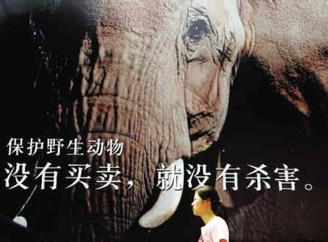

范文一：
A thought-provoking dialogue between the mother elephant and her own child appears in the first picture. Having growing his teeth, the young elephant is eager to share the exciting news with his mother. However, after repeating his words several times, there is still no response coming from the mother. Meanwhile, the attractive caption in the second photo reads: no trade, no kill.
The above pictures unveil a hazard posed to wildlife due to the expanding scale of world commercial hunting. At least two fundamental factors could contribute to this phenomenon. The industry of commercial hunting have undergone a booming expansion (along with the growing public awareness of the merits of wildlife, which makes/), making hunting unusually profitable. Worse still, lacking knowledge regarding the significance of ecological balance, some people take the gun to chase animals insatiably (and thus cause a severe threat to all life in the world). Apparently, this trend will surely in turn endanger humankind in the long run.
(On no account should we turn a blind eye to such things.//All these factors above make it crucial to take drastic measures to protect the wildlife.) Accordingly, governments all over the world are supposed to unite to work out effective measures against commercial hunting. Additionally, people should be educated from childhood to cultivate the awareness that we and the rare wild animals share the same precious planet. I do believe a harmonious relationship between the wildlife and human beings is awaiting us if we make every effort to promote wildlife protection both nationally and internationally.

范文二：
The drawing does mirror a common social phenomenon and is really thought-provoking. According to the above photo, a couple of elephants are walking forward slowly while the young elephant says to his mother, “Mom, my tusks start to grow up!
But mom, why aren’t you happy about that?”What is conveyed carries the message of the human’s threat on the wild animals by catching and killing.
A host of reasons may make this happen. To start with, an army of hunters have been killing rare wild animals just to make huge profits. That is the very reason why the mother elephant does not glad to hear that her son’s ivory growing. Another significant cause of the rapid reduction of wildlife is the disappearance of their natural habitats. Because the urbanization is advancing fast, forcing the animals give up their original places and change another site which may not be as good as before.
Accordingly, it is imperative for us to take drastic and effective measures to protect the wildlife. On the one hand, we can appeal to the government to make some strict laws to prevent them from being caught and killed. On another level, we must enhance citizen's awareness that loving the nature is everybody's responsibility. Only through these measures are we able to have opportunities to expect a beautiful world and a promising prospect to come.

书信作文预测：投诉信、咨询信、请求信、祝贺信、申请信、感谢信

投诉信
Direction: You just bought an English dictionary from a famous e-commerce site only to find it not as good as you expected. Write an email to the customer service center to
1) complain the poor quality of the dictionary, and
2) give reasons for your complaints.
Dear Mr. Wang,
As a regular customer, I am writing this letter to complain about the quality of dictionary bought from the bookone.com.
I ordered an Oxford Dictionary of Contemporary English a week ago. Apart from the delayed delivery, many pages in the dictionary are missing and some of the pages are reversed, which are totally unacceptable to me.
I would like to get a refund or at least change it for a new one. And trust that you will now consider this matter seriously and make an effort to prevent the recurrence of this kind.
Yours sincerely,
Li Ming
询问信
Write a letter inquiring about a travel agency about the trip to Mount Huangshan. Some necessary details must be included. Do not sign your own name at the end of your letter, using “Li Ming” instead.

Dear Sir or Madam,
I would like to travel to Mount Huangshan this summer. I would be most grateful if you could send me information regarding the following information concerned in your agency because my friend John spoke highly of your service.
My family will come with me. Therefore, I would like to know the details about this trip, such as the accommodation, the plans and the money we will cost. By the way, how do you deliver these materials to me? What’s the deadline before we make the final decision? How do I pay for you?
Thank you for your attention. I am looking forward to your immediate response.
Yours sincerely,
Li Ming

请求信
Directions: You find your study load is too heavy. Write a letter to your college teacher:
1） you need to withdraw from two courses,
2） explain the reasons,
3） ask if it is possible to obtain a refund.
Dear Professor Smith,
I am writing to formally request to withdraw from two courses: Introduction to Elementary Education and Teaching Methods.
The main reason for reducing my course load is that I am finding it extremely difficult to manage six courses. Because I really have to work part time, I have no other choice but to decrease my course load. Besides, I would also like to request a tuition refund. I am sorry for any inconveniences I have caused by this change in plans. This decision was not taken lightly, and I do appreciate the kind consideration you have shown to me.
Thank you for your attention to these requests. If you have any questions, please feel free to contact me at 82036600. I look forward to hearing from you soon.
Yours sincerely,
Li Ming

祝贺信：
Directions：Your friend Smith told you he had started his own business .Write a letter to him to congratulate him and give him some helpful suggestions.
Dear Smith,(大家注意此处是逗号)
I was happy to learn that you had opened your own firm and I would like to express my warmest congratulations.
The final realization of your long-cherished dream should be attributed to your diligence, persistence and ambition. I am glad that your consistent pursuit of dream is rewarded now. As a good friend of you, I advise you to keep your ambition. Moreover, in response to challenges, please never to overestimate the difficulties and underestimate your ability.
Please accept my congratulations again. And I do believe you and your firm will achieve one success after another.
Sincerely yours,（逗号）
Li Ming（无符号，千万不要打点）

感谢信
Directions:
You have just returned from a visit to a university in Great Britain. And you were warmly treated there by Professor Smith. Please write a letter to express your thanks to him for his hospitality.
Dear Prof. Smith,
I would like to thank you very much for your kind hospitality and the honor you showed me during my recent visit to your university.
It was nice of you to introduce me so many of famous professors and celebrated scholars at your university. I feel obliged to you for the selfless assistance you render me. I appreciate it more than I can say.
Finally, I wish I can have an opportunity to repay your kindness when you come to China in the near future. Again with many thanks.
Sincerely yours,（逗号）
Li Ming（无符号，千万不要打点）
申请信：
Directions:
You want to apply for the following job: a personal secretary to the general manager, write a letter to Mr. Byron to:
1) show your interest,
2) describe yourself, and
3) explain why you would be suitable for the job.

Dear Mr. Byron,
I am writing to apply for（求职） the position as the personal secretary to the general manager./（求学）(the opportunity for further study in your university).
I am fully confident that I am the right candidate. To begin with, I major in secretary and will graduate from Peking University. I have a good academic performance in school and have been the top five students for four years in my grade. In addition, I am an open-minded, cooperative and ready-to-help girl.
Enclosed is my resume to provide additional information. Thank you for your time and consideration. I am looking forward to your reply at your earliest convenience.
Yours sincerely，
Li Ming

